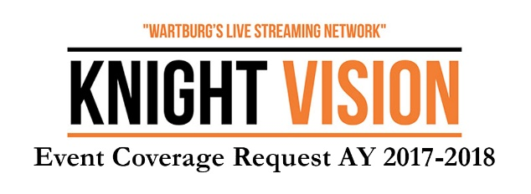
The Knight Vision Executive Team will plan the streaming season for AY 2017-2018 in June 2017. Any events beyond the standard coverage set for sports, ministry, music and special events will be considered on a case by case basis by the KV Executive Team. To be considered for the AY 2017-2018 streaming season, please fill out this form and return to Dr. Penni Pier by May 19, 2017. Only streamed events will be considered, Knight Vision does not provide general audio visual service or commercial work.

Name of Contact: ______________________________ Email: ______________________________

Name of Event: ________________________________ Time/Location: ________________________

Description of Event (Please provide a detailed narrative. Include how the live streaming of this event supports the mission of the college and promotes the “Wartburg Story.”):

Anticipated attendance: _______________ Is there a charge to attend the live event?: ____________

